 **NAME**: James Bond

 **AGE**: 40

 **GUN**: Revolvers, Colt, 45

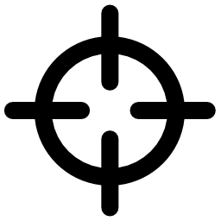

**KILLED PEOPLE:**

|  |  |
| --- | --- |
| **Dr Evil** | 05.05.65. |
| **Moneypenny** | 05.05.67. |
| **Spectre** | 05.05.68. |